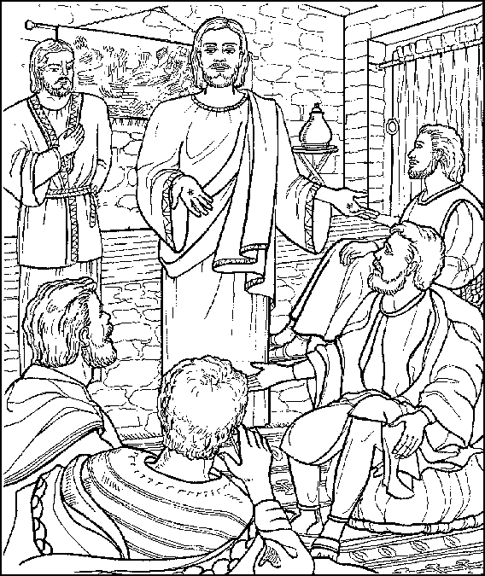
Blessed are those who have not seen
and yet have believed."
John 20:29b

Second Sunday of Easter
April 16, 2023

Welcome! We are glad you are here! In worship, we gather before the almighty God to offer him the praise that is due his name and to be fed by his life-giving Word. This service folder will guide you through our path of worship. If you have any questions, please don’t hesitate to ask an usher or the person sitting next to you. God bless your time in this house of God.

Bathrooms are located in the fellowship hall. A changing table is located in the women’s bathroom.

A worship monitor is to the right as you exit. We encourage children of all ages to participate in our worship. Please bring them into the service. We have a nursery room with toys, books, and other items that you can use with your child.
Before you leave, please sign our guest register. Located on the lectern in the entryway.

OPENING HYMN Jesus Lives! The Victory’s Won CW145
M: In the name of the Father and of the Son and of the Holy Spirit.
C: Amen.
Confession and Absolution
M: God so loved the world that while we were yet sinners, Jesus Christ was given to die for us. Through the power of the Holy Spirit, God promises to heal us and forgive us. Let us confess our sins in the presence of God and one another.
Silence for personal reflection
M: Jesus invites you: “Come to me, all you who are weary and burdened, and I will give you rest.” (Matthew 11:28)
C: We have come to the Lord’s house wearied by our work and burdened by our problems.

M: Isaiah said of the Savior: “A bruised reed he will not break,” (Isaiah 42:3) and again: “He was bruised for our iniquities . . . by his wounds we are healed.” (Isaiah 53:5)
C: We have come bruised by the actions of others and bruised by our repeated falls into sin.
M: Isaiah says that God the Father sent Jesus “to bind up the brokenhearted, to proclaim freedom for the captives . . . to comfort all who mourn.” (Isaiah 61:1-2)
C: We come broken in spirit because we cannot pay for our wrongs, broken in heart because we long for the peace of forgiveness.
M: God, our heavenly Father, has been merciful to us and has given his only Son to be the atoning sacrifice for our sins. Because of Jesus’ atoning work God assures us in the Bible:
C: “As far as the East is from the West, so far has he removed our transgressions from us.” (Psalm 103:12)
M: He says, “I will forgive their wickedness and I will remember their sins no more.” (Jeremiah 31:24)
C: “The blood of Jesus, his Son, purifies us from all sin.” (1 John 2:7)
M: After his resurrection, Jesus appeared to his disciples and said, “Receive the Holy Spirit.
C: If you forgive anyone his sins, they are forgiven.” (John 20:22,23)
M: Therefore, as a called servant of Christ and by his authority, I forgive you all your sins, in the name of the Father, and of the Son and of the Holy Spirit.
C: Amen. May the God of hope fill us with joy and peace in believing. Amen.

Prayer and Praise
M: In the peace of forgiveness, let us praise the Lord:
“I Lay My Sins on Jesus”

I lay my sins on Jesus, The spotless Lamb of God;
He bears them all and frees us From the accursed load.
I bring my guilt to Jesus To wash my crimson stains
White in his blood most precious Till not a spot remains.

PRAYER OF THE DAY

M: O risen Lord, you came to your disciples and took away their fears with your word of peace. Come to us also by your Word and sacrament, and banish our fears with the comforting assurance of your abiding presence; for you live and reign with the Father and the Holy Spirit, one God, now and forever.

C: Amen.
The Word

FIRST LESSON Acts 2:14a, 22-32

PSALM OF THE DAY Psalm 16 (CW pg. 68)

SECOND LESSON 1Peter 1:3-9

GOSPEL ACCLAMATION

M: Alleluia. Blessed are those who have not seen and yet have believed. Alleluia.
SEASONAL RESPONSE
C: ♫ I rest my soul on Jesus, This weary soul of mine.
His right hand me embraces; I in his arms recline.
I love the name of Jesus, Immanuel, Christ, the Lord;
Like fragrance on the breezes His name abroad is poured.

GOSPEL John 20:19-31
M: This is the Gospel of the Lord.
C: Praise be to you, O Christ!

HYMN OF THE DAY O Sons and Daughters of the King CW165

SERMON

NICENE CREED
We believe in one God, the Father, the Almighty,
maker of heaven and earth,
of all that is,
seen and unseen.
We believe in one Lord, Jesus Christ, the only Son of God,
eternally begotten of the Father,
God from God, Light from Light, true God from true God,
begotten, not made,
of one being with the Father.
Through him all things were made.
For us and for our salvation, he came down from heaven,
was incarnate of the Holy Spirit and the virgin Mary,
and became fully human.
For our sake he was crucified under Pontius Pilate.
He suffered death and was buried.
On the third day he rose again in accordance with the
Scriptures.
He ascended into heaven
and is seated at the right hand of the Father.
He will come again with glory to judge the living and the dead, and his kingdom will have no end.

We believe in the Holy Spirit,
the Lord, the giver of life,
who proceeds from the Father and the Son,
who in unity with the Father and the Son is worshiped
and glorified, who has spoken through the prophets.
We believe in one holy Christian and apostolic Church.
We acknowledge one baptism for the forgiveness of sins.
We look for the resurrection of the dead
and the life of the world to come. Amen.

OFFERING We joyfully respond to our Shepherd’s loving care by praising him with all we are and all we have. Bringing an offering is an act of trust in God’s promises to provide and an acknowledgement that “my cup overflows.” A joyful and generous offering is always a wonderful way to show Jesus that he is our greatest treasure and worthy of our praise. May God be praised through our offerings!

PRAYER OF THE CHURCH

M: Lord Jesus Christ, you have made known to us the path of life. You have made our joy complete.
You are our Lord.
C: Apart from you we have no good thing.

M: Give us your gift of peace and drive all doubt from our hearts with the gospel of your resurrection, that we may face all troubles with boldness and confidence.
You are our Lord.
C: Apart from you we have no good thing.

M: Have mercy on those who live in doubt, who live without hope, and even those who oppose your gospel. In your grace prepare their hearts and give them opportunities to hear your gospel again.
You are our Lord.
C: Apart from you we have no good thing.

M: Lead and guide all in authority, the President of the United States, the governor of this state, all legislatures and courts, that peace may prevail among us, and that we may remain free to openly worship you as our Lord and our God.
You are our Lord.
C: Apart from you we have no good thing.

M: Strengthen and keep those who proclaim your Word in your grace that they may boldly proclaim the gospel they have heard and bring many more into fellowship with you and your church.
You are our Lord.
C: Apart from you we have no good thing.

M: Risen Lord, with you there is no doubt, but the worries and cares of the world and the burdens in our hearts weigh us down. Lighten the burdens of those who struggle, [especially…] that they may never doubt your Word or your goodness, but find their life and light in you.
You are our Lord.
C: Apart from you we have no good thing.

Special prayers and intercessions may follow.

M: Listen, Lord, to the thoughts and cares of our hearts.

Silent prayer

M: Lord Jesus Christ, true God and truly human, you do not change, and you are holy in all your works. Remove all our unbelief and doubt and fill our hearts with the gifts of your grace that we may believe and know you as our Lord and our God; you live and reign, now and forever.

C: Amen.

LORD’S PRAYER

C: Our Father, who art in heaven, hallowed be thy name, thy kingdom come, thy will be done on earth as it is in heaven. Give us this day our daily bread; and forgive us our trespasses, as we forgive those who trespass against us; and lead us not into temptation, but deliver us from evil. For thine is the kingdom and the power and the glory forever and ever. Amen.

THE SACRAMENT
These responses mark the beginning of the Sacrament section of the service and lift the worshipers’ hearts in praise. The opening sentences are among the oldest in the Christian liturgy.

M: The Lord be with you.
C: And also with you.

M: Lift up your hearts.
C: We lift them up to the Lord.

M: Let us give thanks to the Lord our God.
C: It is good and right so to do.

M: Praise to the God and Father of our Lord Jesus Christ! In love he has blessed us with every spiritual blessing. He raised Christ from the dead and seated him at his right hand in the heavenly realms and placed all things under his feet for the benefit of the Church. Now have come the salvation and the power and the kingdom of our God and the authority of his Christ. To Him who sits on the throne and to the Lamb be praise and thanks and honor and glory forever and ever.

HOLY, HOLY, HOLY (Sanctus)

C: Holy, holy, holy is the Lord of hosts. The whole earth is full of your glory. You are my God, and I will exalt you. I will give you thanks, for you have become my salvation. Holy, holy, holy is the Lord of hosts. The whole earth is full of your glory.
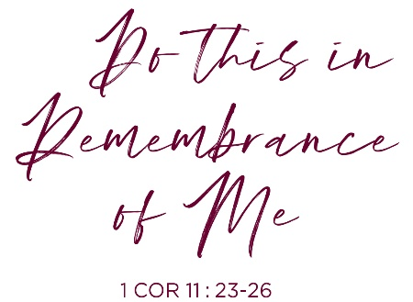
WORDS OF INSTITUTION
Our Lord Jesus Christ, on the night he was betrayed, took bread; and when he had given thanks, he broke it and gave it to his disciples, saying, “Take and eat; this is my body, which is given for you. Do this in remembrance of me.”

Then he took the cup, gave thanks, and gave it to them, saying, “Drink from it, all of you; this is my blood of the new covenant, which is poured out for you for the forgiveness of sins. Do this, whenever you drink it, in remembrance of me.”
The peace of the Lord be with you always.

C: Amen.

O CHRIST, LAMB OF GOD (Agnus Dei)

C: O Christ, Lamb of God, you take away the sin of the world; have mercy on us. O Christ, Lamb of God, you take away the sin of the world; have mercy on us. O Christ, Lamb of God, you take away the sin of the world; grant us your peace. Amen.

DISTRIBUTION
(To our visitors: As we celebrate Holy Communion, we want you to be able to commune with us! But we also want you to be aware that we believe, from Scripture, that when you commune with a group of Christians, you are indicating you are in doctrinal agreement. Therefore, if you are not a member of our church or of a church in fellowship with us, we kindly ask you to refrain from communing with us until you have had a chance to declare your agreement with what we teach. If you would like to take such a step or would like further explanation on this, please don’t hesitate to speak to the pastor after the service.)

COMMUNION HYMN How Firm a Foundation CW 416

SONG OF SIMEON

C: Lord, now you let your servant depart in peace according to your word. For my eyes have seen your salvation, which you have prepared before the face of all people, a light to lighten the Gentiles and the glory of your people Israel.

O God the Father, source of all goodness, in your loving kindness you sent your Son to share our humanity. We thank you that through him you have given us pardon and peace. We also pray that you rule in our hearts and minds by your Holy Spirit so that we willingly serve you day after day, through Jesus Christ, our Lord, who lives and reigns with you and the Holy Spirit, one God, now and forever.

C: Amen.

BLESSING

Brothers and sisters, go in peace. Live in harmony with one another. Serve the Lord with gladness.
The Lord bless you and keep you.
The Lord make his face shine on you and be gracious to you.
The Lord look on you with favor and give you peace.

C: Amen. Amen. Amen.

CLOSING HYMN This Is the Threefold Truth CW406

Come worship with us again!
Next Sunday, April 23rd - 2:00 pm

VACANCY PASTOR

Christopher Hoppe, Pastor stjohnluthvaca@outlook.com
(920) 652-4003 www.stjohnvacaville.org
christopherhpp@gmail.com

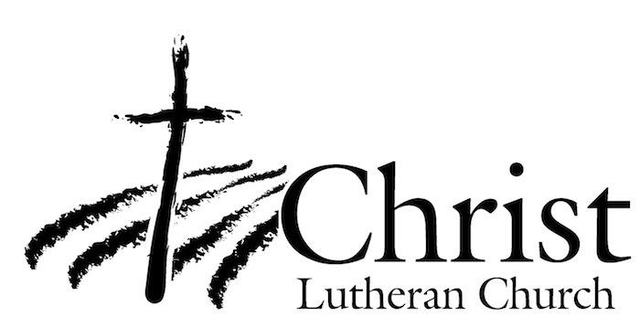
13009 N. Elderberry Ct.
Lodi, CA 95242
www.christlodi.org
209-368-6250
WELCOME TO CHRIST EV. LUTHERAN CHURCH!
We preach a message of forgiveness, hope and peace
through the death and resurrection of Jesus Christ.
Families and individuals of all ages will find opportunities
both to grow and to serve.

Our mission statement:
Look what Christ is doing!
He binds us together in fellowship
He gathers us in for worship
He builds us up for service
He sends us out with the gospel

“Now you are the body of Christ,
and each one of you is a part of it.”
(1 Corinthians 12:27)

